Herbarium Lesvos 2024

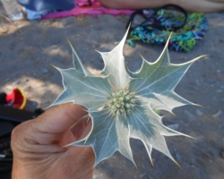
Seaholly/Eryngium maritimum – eatible – from Kroussos
Other name: Sea Eryngo
- young shoots can be eaten as asparagus
- the roots can be candied as sweets (they are good for flatulence)
medical effect – diuretic, stimulant, aphrodisiac, stone inhibitor, expectorant, anthelmintic, antimicrobial (including against E. cola)

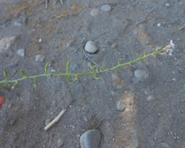
Searocket/Cakile maritima – eatible – from Kroussos
Other name: European searocket
From the mustard family.
The leaves are edible (preferably cooked, but you can't eat too many of them).

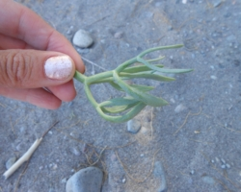
Seafennel/Crithmum maritimum – eatible (and delicious) – from Kroussos
Other names: Samphire, Rock samphire
- tasty cooked and stewed (Used in traditional dishes)
- you can make pickles in oil or ccie
properties - nutritional and antioxidant

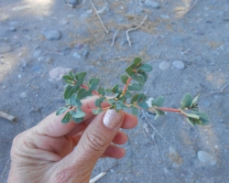
Euphorbia peplis – toxic – from Kroussos

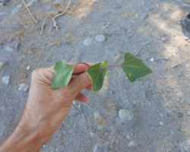
Cocklebur/Xanthium Strumarium/Bardana – toxic – from Kroussos
Small amounts of mature parts of the plant can be eaten, although they too contain toxic substances.
The seeds and shoots are toxic.

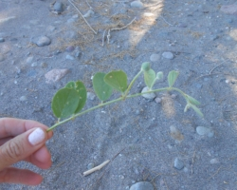
Caper/Capparis Spinosa – eatible – our dear Capers – with beautiful flower – from Kroussos
Culinary use in pickles.

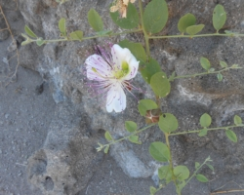
Caper/Capparis Spinosa – eatible – our dear Capers – with beautiful flower – from Kroussos

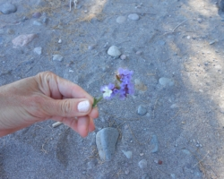
Sea Lavender/Limonium sp. – decorative – from Kroussos
Used in tanning and in the production of black, pink, yellow and green dye for leather and carpets.

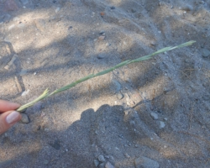
Sand couch Grass – a kind of wheat, for flour – from Kroussos
Other names: Salt couch Grass, Marine couch, Sporobolus virginicus
flour supplement

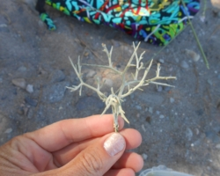
Witches’ cushion/Euphorbia acanthothamnos – not eatible, and don’t sit on it! – from Kroussos
Other names: Thorn Bush, Greek spiny spurgge, Thorn cushion
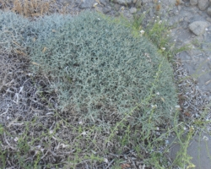
Witches’ cushion/Euphorbia acanthothamnos – not eatible, and don’t sit on it! – from Kroussos

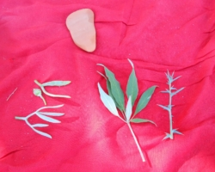
At the centre Sauzgatillo/Vitex agnus-castus, for tea, very good for menopause – from Kroussos

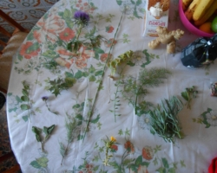
plants from Kroussos
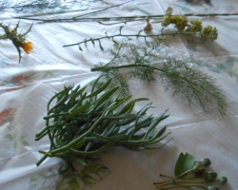
Plants from Kroussos -
Top left: Ferula sp. -
Second from top right: scolymus hispanicus
Bottom left: Seafennel/Crithmum maritimum – eatible (and delicious)

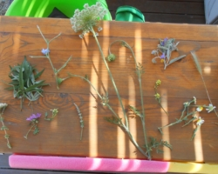
plants from Eresssos

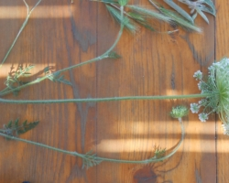
Wild Carrot/Daucus Carota – root eatibleand flour for cosmetics – from Eressos
- edible roots, leaves and seeds
- flowers are suitable for making tonic (although they can also cause allergies)
- seeds and flowers have been used as agents to prevent and spend pregnancy
- supports other crops

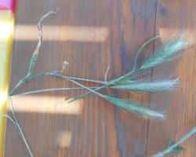
Wild Wheat/Triticum Boeoticum – seeds eatible, like wild oat, also avaibale around – from Eressos
Other name: Einkorn wheat
- edible after shelling
- later domesticated species

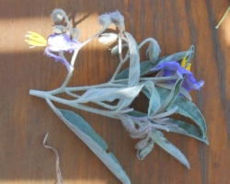
Solanum elaeagnifolium/Solanum sp./Silver leaf nightblade/Quillo – poisonous – from Eressos
Other names: Sliverleaf nightshade, Silver-leaved nightshade

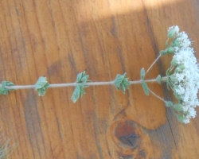
Origanum Onites – A kind of Oregan – eatible -from Eressos

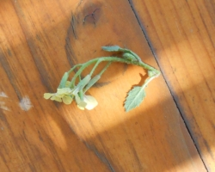
Radish – Cruciferae family – – eatible – from eressos

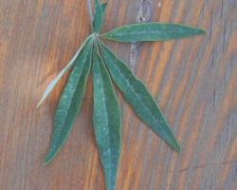
Sauzgatillo/Vitex agnus-castus, for tea, very good for menopause – from Eressos
- therapeutic effect in menstrual disorders
- estrogenic effect in menopause
Used in Greece during the women's agricultural festival Thesmophoria in honor of Demeter and Persephone (also on Samos).

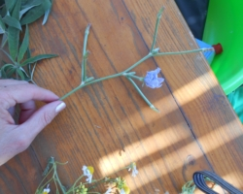
Common chicory/Cichorium intybus – eatible – from Eressos
From family Asteraceae
- for salad leaves, chicons (blanched buds), or roots, which are baked, ground, and used as a coffee substitute and food additive
- used in food manufacturing as a sweetener and source of dietary fiber
- grown as a forage crop for livestock
medical effect – in herbal medicine used since prehistoric times, also in homeopathy, and it has anti-cancer properties
According to legend, chicory flowers owe their blue color to the eyes of a girl weeping for her lost beloved.

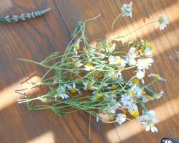
Camomile/Matricaria chamomilla – for tea – from Eressos

- oil is used in medicine and cosmetics
- digested orally as an oil it is anti-inflammatory and antispasmodic for the digestive system, and also has an anti-allergic effect
- used externally as an infusion it counteracts inflammation of the skin, it also helps for skin ulcers, hemorrhoids, erythema, sunburn , and thermal burns of the first and second degree.
- used internally as an infusion in intestinal and gastritis

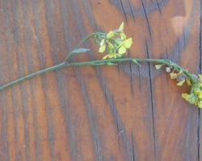
Hoary mustard/Jaramago/Sinapsis arvensis – eatible! – from Eressos

- leaves are edible and traditionally were used in some areas as a leaf vegetable

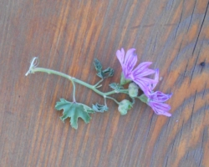
Mallow/Malva silvestris – medicinal and decorative – from Eressos
- the whole or broken, dried flowers and leaves are used as a covering and emollient externally and internally in rhinitis and inflammatory conditions of the respiratory tract (protects mouth, throat, and larynx from irritation, it also soothes coughs, restores the movement of the ciliary epithelium, facilitates expectoration and reduces inflammation)
It is one of the plant materials that can be used in young children and infants.
Used in the form of an infusion.
For medicinal purposes, freshly developed flowers are harvested from June to August during the bloom period, picking them by hand without stalks and trying not to crush the crowns. It is dried quickly spread out in a thin layer in the shade and air to preserve its beautiful blue-purple color.
In the past it was eaten as a vegetable. Young leaves and shoots of mallow were used to make herbal soup, salad and side dishes.
Dried leaves were used to make tea.
The flowers were added to salads.

